February 26, 2024
Ref: IIH/MD/2024/02/003
His Excellency,
The Executive Governor of Kwara State,
Government House,
Ahmadu Bello Way,
GRA, Ilorin, Kwara State.
Dear Sir,
REQUEST TO OBTAIN ILORIN INNOVATION HUB REGISTRATION DOCUMENTS
As we near completion of our project and approach budgeting and hiring, we need to finalize the administrative documents and registration for the Ilorin Innovation Hub. Sequel to the previous registration by Harmony Holdings Limited and subsequent your change of plans to have the ownership of Ilorin Innovation Hub Limited (RC number 1664691) to be 100% owned by the Kwara State Government (via its representatives), I ask for your approval for for Harmony Holdings Limited to hand over the Corporate Affairs Commission (CAC) registration documents so that a change of ownership on the private limited company can be effected.
Thank you for your continued support Sir.
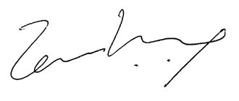

Temi Kolawole
ag. MD Ilorin Innovation Hub

